JAVA->

Java is a **programming language** and a **platform**.

Java is a high level, robust, secured and object-oriented programming language.

**Platform**: Any hardware or software environment in which a program runs, is known as a platform. Since Java has its own runtime environment (JRE) and API, it is called platform.

Concept of- “virtual machine “that execute byte code no matter hardwear or operating sys.

First program of java->

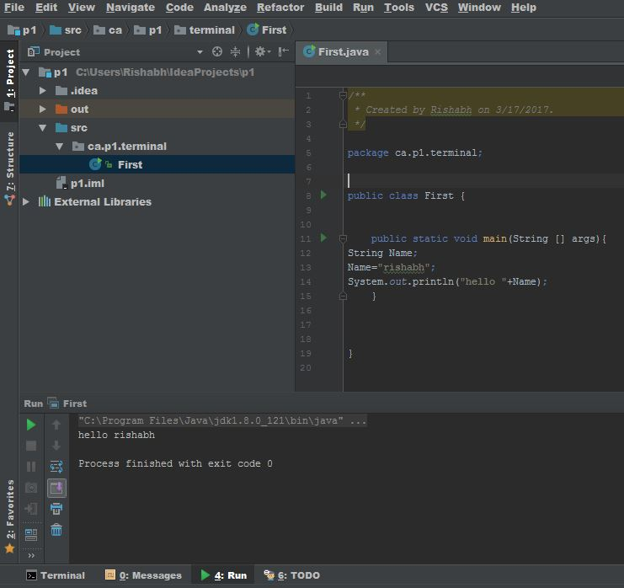

Java uses ->

! mobile

! games

! robotics

! web applications //irctc

! desktop application// media player

! enterprise application // like bank:means a application which work for only some people;

Types Of Java Application->

1.stand Alone Application-> its also known as a windows application An application that we need to install on every machine such as media player, antivirus etc.

2.Web Application->an Application that run on server side and create dynamic page is called web Application.

3.Enterprise Application->An application that is distributed in nature, such as banking applications etc. It has the advantage of high level security, load balancing and clustering. In java, EJB is used for creating enterprise applications.

4.Mobile Application->an Application that runs on mobiles.

Difference between JDK, JRE and JVM->

JVM-> (java virtual machine) is an abstract machine.this machine provides the runtime enviorment which converts the byte code into the executable code.

// JVMs are available for many hardware and software platforms. JVM, JRE and JDK are platform dependent because configuration of each OS differs. But, Java is platform independent.//

//

JRE->(java run time environment)

It is used to provide runtime environment. It is the implementation of JVM. It physically exists. It contains set of libraries + other files that JVM uses at runtime.

Jdk->(java development kit)

It contains JRE + development tools.

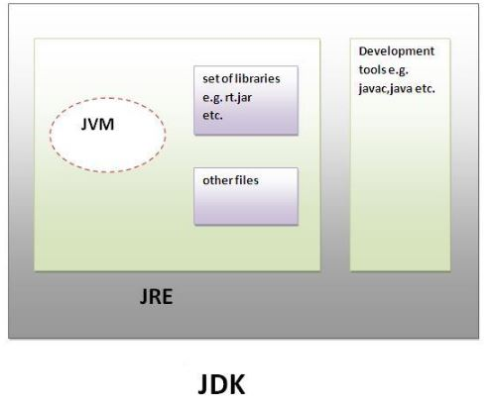

HOW JAVA CODE RUN ON ANY PLATFORM->

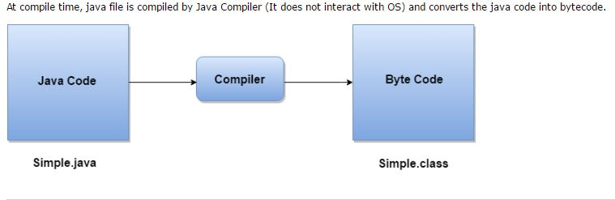

JAVA IS COMPILER AS WELL AS INTERPRETER->

DIFFRENCE B/W COMPILER AND INTERPRETER->

1.COMPILER CHECK WHOLE CODE THEN EXECUTE but INTERPRETER EXECUTE LINE BY LINE AND CHECK AT THE TIME ITS EXECIUTING;

2.SCAN THE ENTIRE PROGRAM AND TRANSLATE.IT AS A WHOLE MACHINE CODE but Translates Program One Statement At A Time

PROGRAM TO IMPLENT SUM AND PRINTING-:

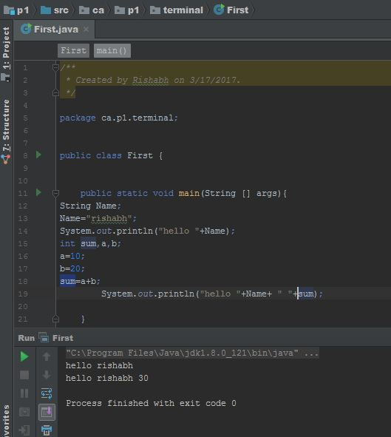

Understanding first java program->

meaning of class, public, static, void, main, String[], System.out.println().

1.class keyword is used to declare a class in java.

2. public keyword is an access modifier which represents visibility, it means it is visible to all.

3. static is a keyword, if we declare any method as static, it is known as static method. The core advantage of static method is that there is no need to create object to invoke the static method. The main method is executed by the JVM, so it doesn't require to create object to invoke the main method. So it saves memory.

4.void is the return type of the method, it means it doesn't return any value.

5. main represents startup of the program.

6. String[] args is used for command line argument.

7. System.out.println() is used print statement.

many ways can we write a java program->

1) By changing sequence of the modifiers, method prototype is not changed.



2) subscript notation in java array can be used after type, before variable or after variable.

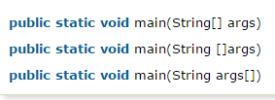

3. and 4.

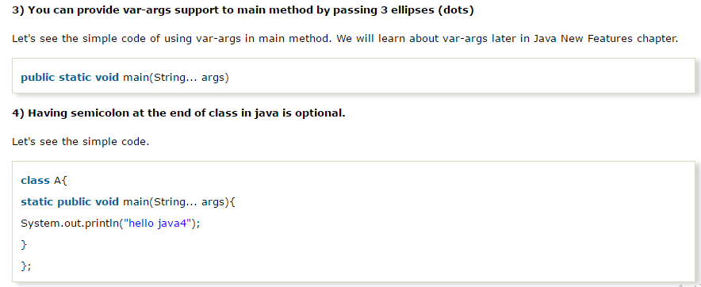

5.valid->

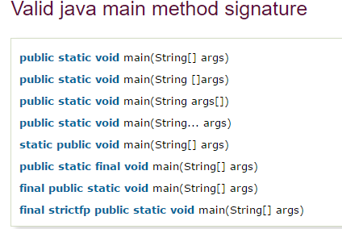

Invalid java main method->

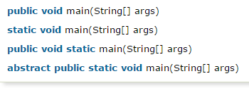

History of JAVA->

1) **James Gosling**, **Mike Sheridan**, and **Patrick Naughton** initiated the Java language project in June 1991. The small team of sun engineers called **Green Team**.

2) Originally designed for small, embedded systems in electronic appliances like set-top boxes.

3) Firstly, it was called **"Greentalk"** by James Gosling and file extension was .gt.

4) After that, it was called **Oak** and was developed as a part of the Green project.

Java Version History->

There are many java versions that has been released. Current stable release of Java is Java SE 8.

1. JDK Alpha and Beta (1995)
2. JDK 1.0 (23rd Jan, 1996)
3. JDK 1.1 (19th Feb, 1997)
4. J2SE 1.2 (8th Dec, 1998)
5. J2SE 1.3 (8th May, 2000)
6. J2SE 1.4 (6th Feb, 2002)
7. J2SE 5.0 (30th Sep, 2004)
8. Java SE 6 (11th Dec, 2006)
9. Java SE 7 (28th July, 2011)

10.Java SE 8 (18th March, 2014)

Java.lang->always import automatically in every class it contains the->

String,System are the class who are mentioned in java.lang;

Debuging means->The process of finding and correcting an

error in a program.